***G.MADEGOWDA INSTITUTE OF THECNOLOGY***

***Hii***

***This project report on***

***“ --DJ MANAGEMENT SYSTEM”***

***For the course***

***Database management system***

***Submitted by ;-)***

***RAVISHANKAR. J (usn: 4mg20cs035)***

***PRIYANKA. S (usn: 4mg20cs032)***

THIRD YEAR ENGINEERING

Guided by

***PROF. SHUSHEELA MAM***

Submitted to

**G. Madegowda institute of technology**

For academic year 2023-2024

|  |  |  |
| --- | --- | --- |
| SL.NO | CHAPTER NAME |  |
| 01 | INTRODUCTION |  |
| 02 | DEVELOPMENT TOOLS |  |
| 03 | SYSTEM REQUIREMENT |  |
| 04 | FEATURES |  |
| 05 | SNAPSHOTS |  |
| 06 | SOURCE CODE |  |
| 07 | FUTURE SCOPE |  |

***CONTENT***

***INTRODUCTION***

The main objective the project is to design a Dynamic, responsive website and an online framework for

***-- DJ MANAGEMENT SYSTEM*** or web application with full-fledged logic and environment using new trending technologies in market with maximum functionalities, efficiency, maximum optimal speed on web and one key feature it must be more informative.

**DEVELOPMENT TOOLS**:-

1. We make our module with php, MySQL.
2. Language: CSS, CSS3, JAVASCRIPT, HTML, PHP, SQL.
3. We used Visual studio as our editor.
4. We use Apache server.
5. Web-Browser: Mozilla Firefox/google Chrome/Opera mini/ Safari/ E11/ Microsoft Edge.
6. Frameworks and Libraries: Bootstrap and Query.

**SYSTEM REQUIREMENTS**:

**On client side:**

* Operating system (any)
* Web Browser (1E8, Mozilla hire fox, Google Chrome, Opera, Safari)

**On Server side:**

* Web Server (Apache)
* Php
* MySQL

**Hardware Requirements:**

**At Server Side**

* P IV or Above Processor
* 1GB RAM
* 120GB HDD/SSD
* LAN or WAN

**FEATURES**:-

* Secure login-logout
* Inexpensive
* User Friendly
* Fully Informative

**SNAPSHOT:**

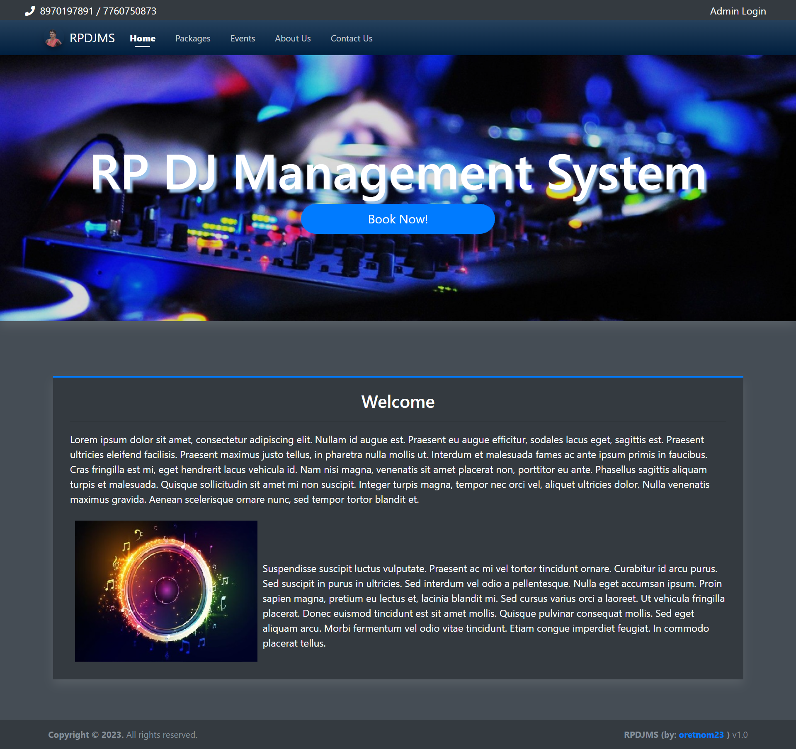

Fig 1-Home page

Home page will used to book the DJ for events and any functions, parties, wedding, night clubs, etc.

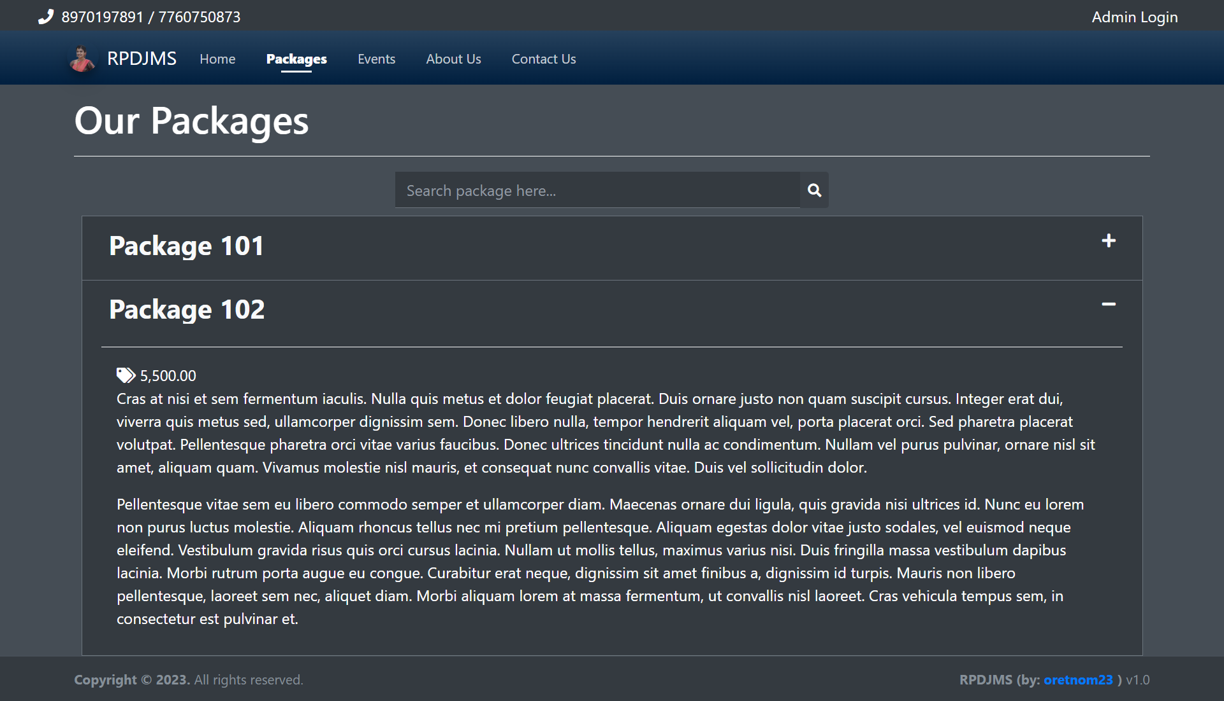

Fig 2-Packages page

Package 101 & package 102 is used to see the price of the DJ for any events, functions, patties, clubs, etc.

In ours webpage there is 2 packages

1. Package 101:-

3500rs package

1. Package 102:-

5500rs package

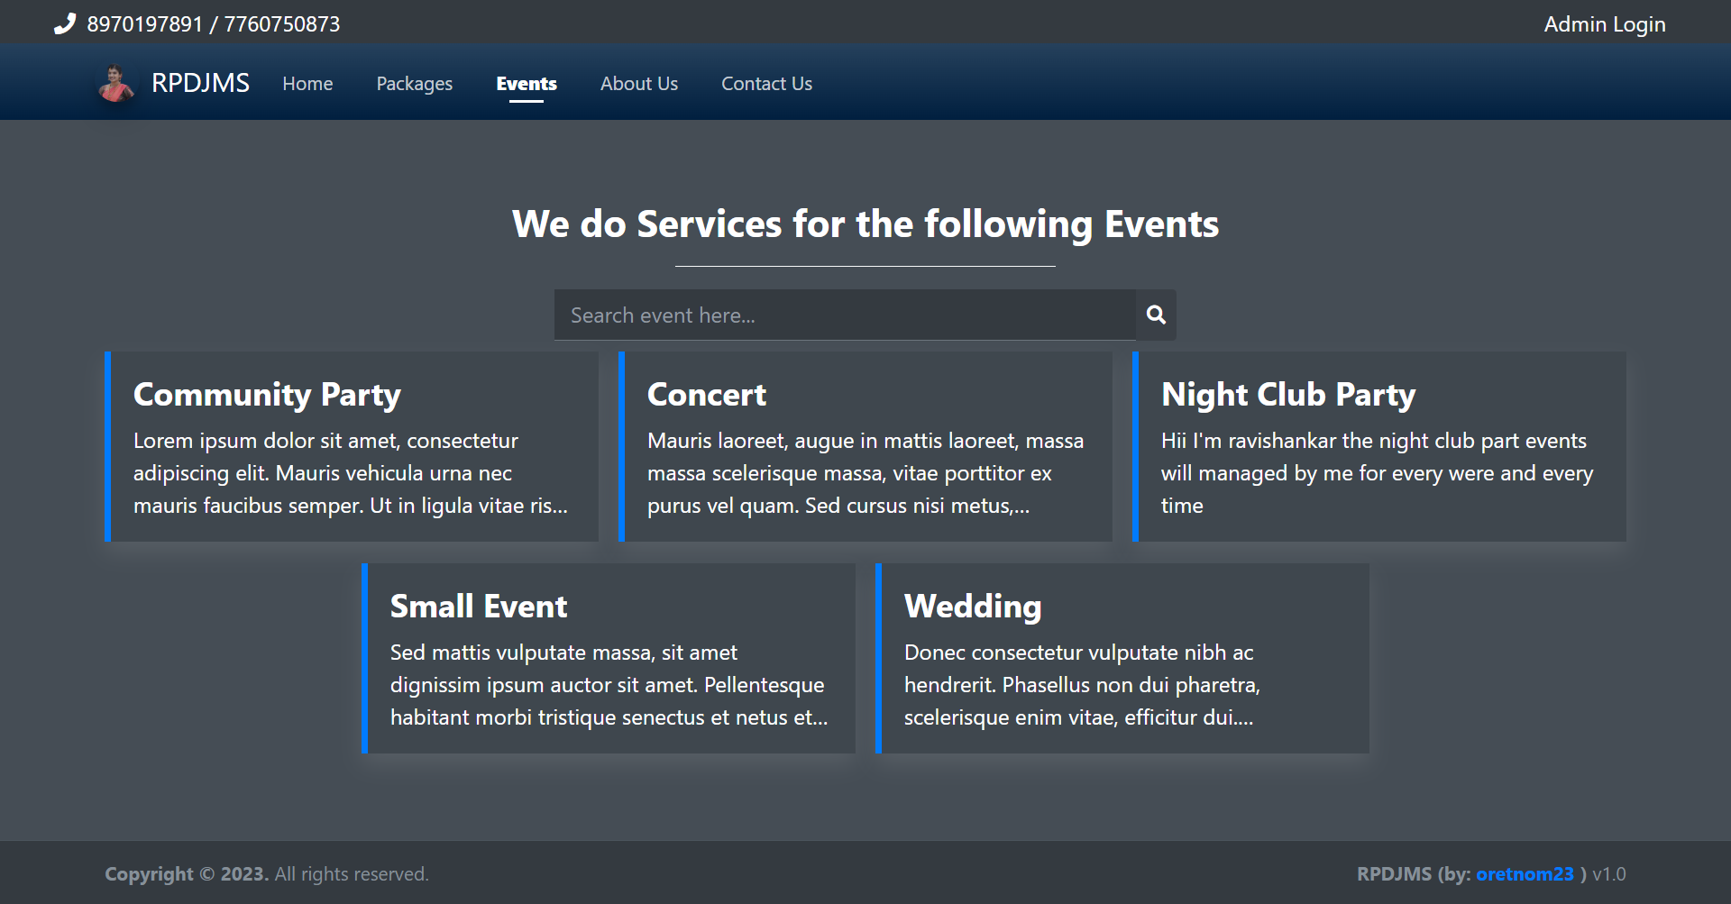

Fig 3-Event management

-In event page we can see the lists of events.

-The event list helpful for user to book the events.

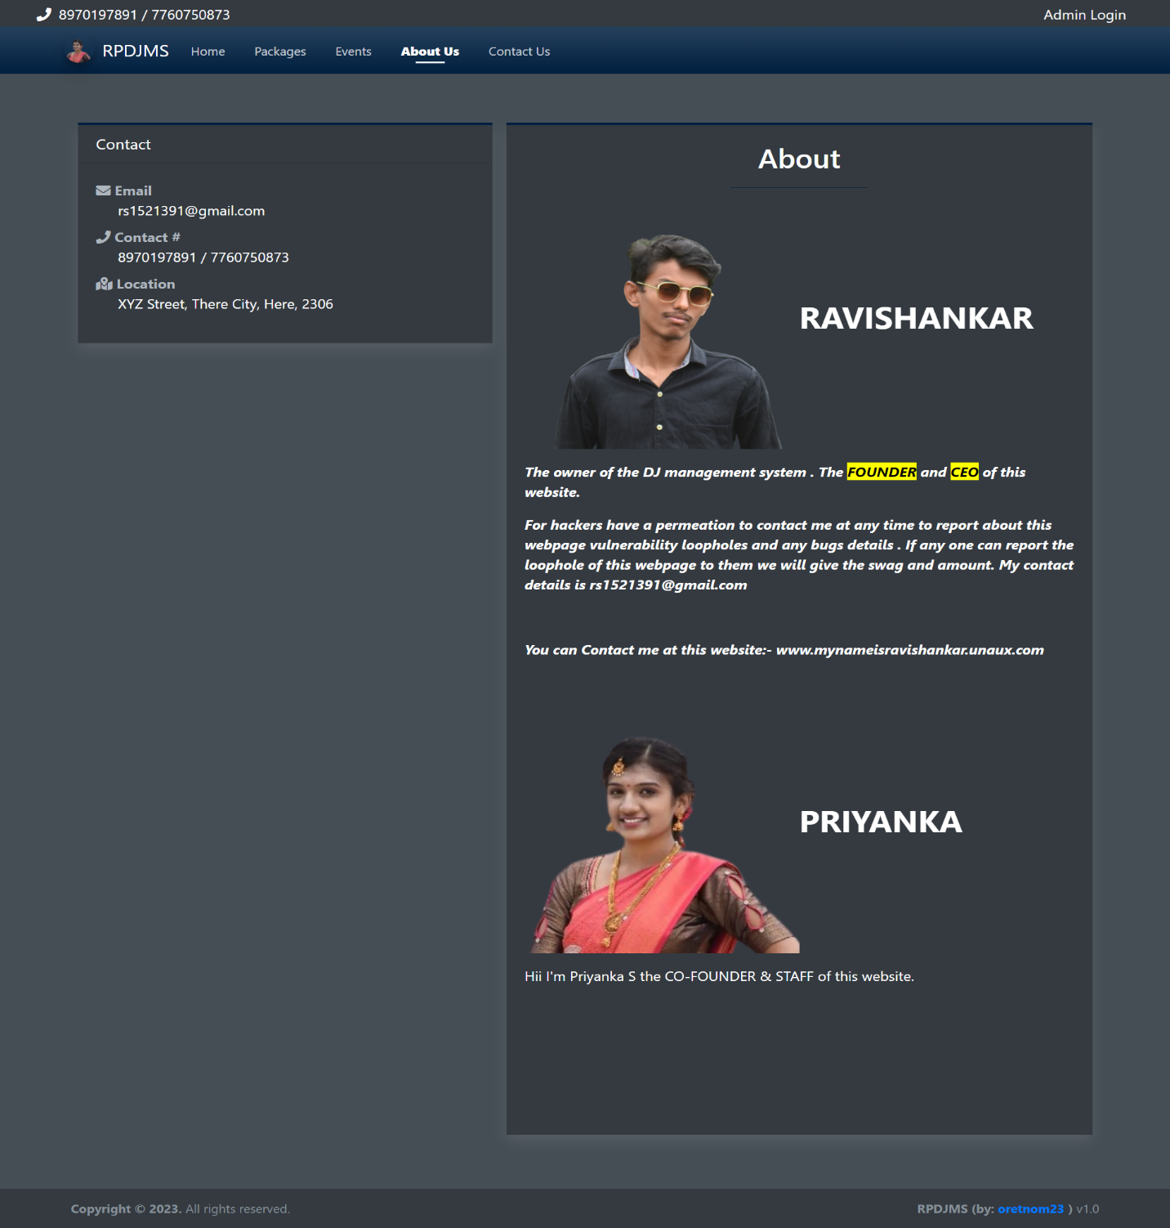

Fig 4-About us page